Lab-7: Configuration of ARP and DHCP

in Cisco Packet Tracer

NAME: K.Yasaswi

ID: 2420030053

Section:2

# Aim:

To con7igure ARP and DHCP on a router in Cisco Packet Tracer, assign IP addresses to PCs dynamically, and verify the con7iguration.

# Apparatus:

1. Cisco Packet Tracer software
2. 1 Router (e.g., 1941)
3. 1 Switch (e.g., 2960)
4. 2 PCs (PC1, PC2)
5. 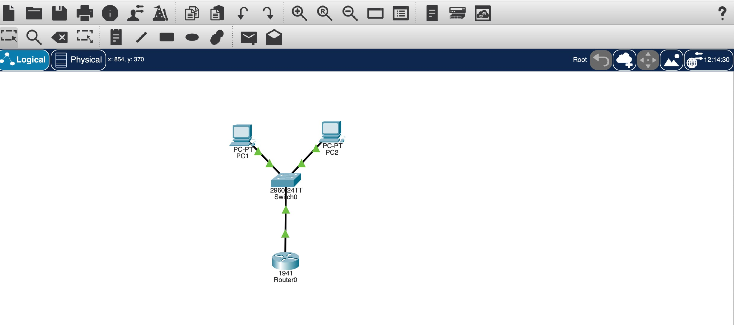Copper straight-through cables

# Procedure:

1. Place Router, Switch, and PCs in workspace.
2. Connect Router GigabitEthernet0/0 to Switch using a copper straight-through cable.
3. Connect PC1 and PC2 to Switch using copper straight-through cables.
4. Turn on all devices and check that ports are powered.
5. Con7igure Router interface GigabitEthernet0/0:

- Assign IP 192.168.10.1 255.255.255.0

* + Enable the interface using `no shutdown`

1. Con7igure DHCP on Router:
   * Exclude router IP: (`ip dhcp excluded-address 192.168.10.1`)
   * Create DHCP pool LAN1

- Network: 192.168.10.0 255.255.255.0

- Default-router: 192.168.10.1

* + DNS-server: 8.8.8.8

1. Con7igure PCs to obtain IP automatically using DHCP.
2. Verify DHCP assignment on PCs using (`ipcon7ig`).
3. Test connectivity by pinging router and other PCs.
4. Verify ARP entries on PCs using `arp -a` and on Router using `show ip arp`.
5. (Optional Command) Verify switch MAC table using `show mac address-table`.

# Commands:(Direct inputs)

enable

con7igure terminal

interface GigabitEthernet0/0

ip address 192.168.10.1 255.255.255.0

no shutdown exit

ip dhcp excluded-address 192.168.10.1 ip dhcp pool LAN1

network 192.168.10.0 255.255.255.0

default-router 192.168.10.1

dns-server 8.8.8.8 exit

exit

# Output:

PC1 IP: 192.168.10.2

PC2 IP: 192.168.10.3

Subnet Mask: 255.255.255.0

Default Gateway: 192.168.10.1

# Verification Commands:

PC> ipcon7ig

PC> ping 192.168.10.1

PC> ping 192.168.10.3

PC> arp -a

Router# show ip dhcp binding Router# show ip arp

Switch# show mac address-table

# Results:

PCs successfully received IP addresses via DHCP. PCs can communicate with each other and router. ARP entries correctly show IP ↔ MAC mappings. Switch and router interfaces are up and functioning.

# Screenshots:

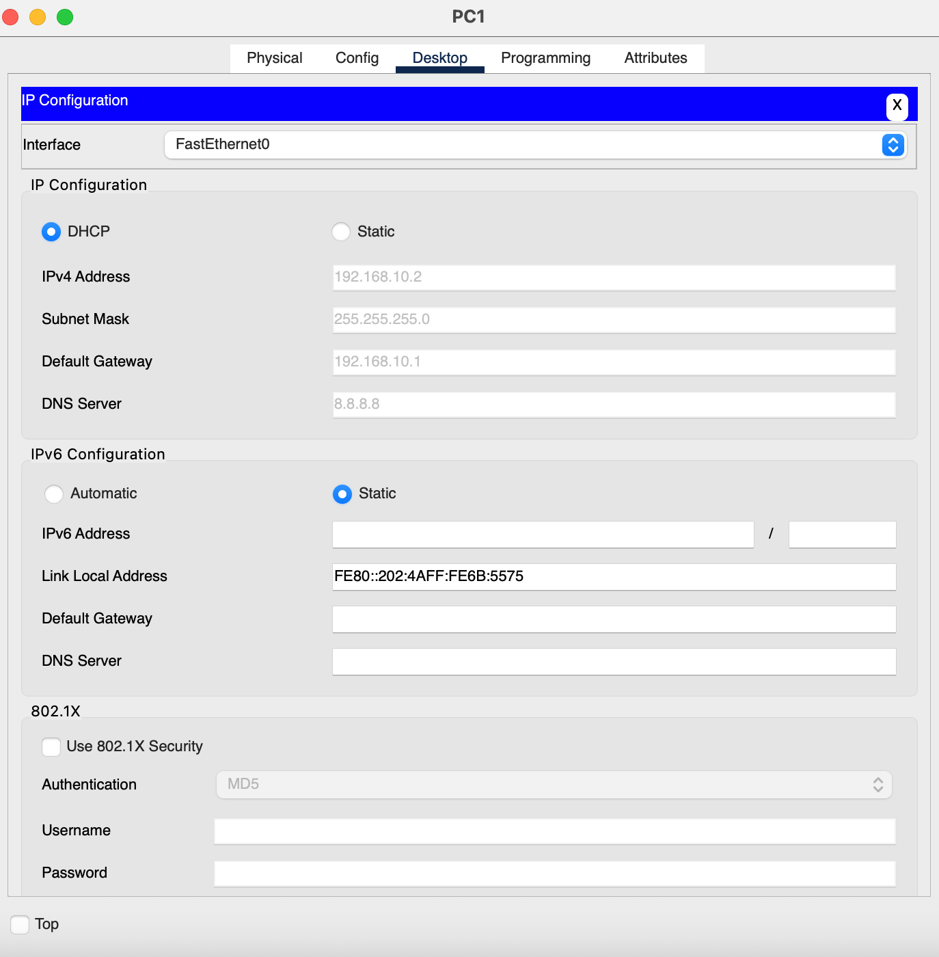

-

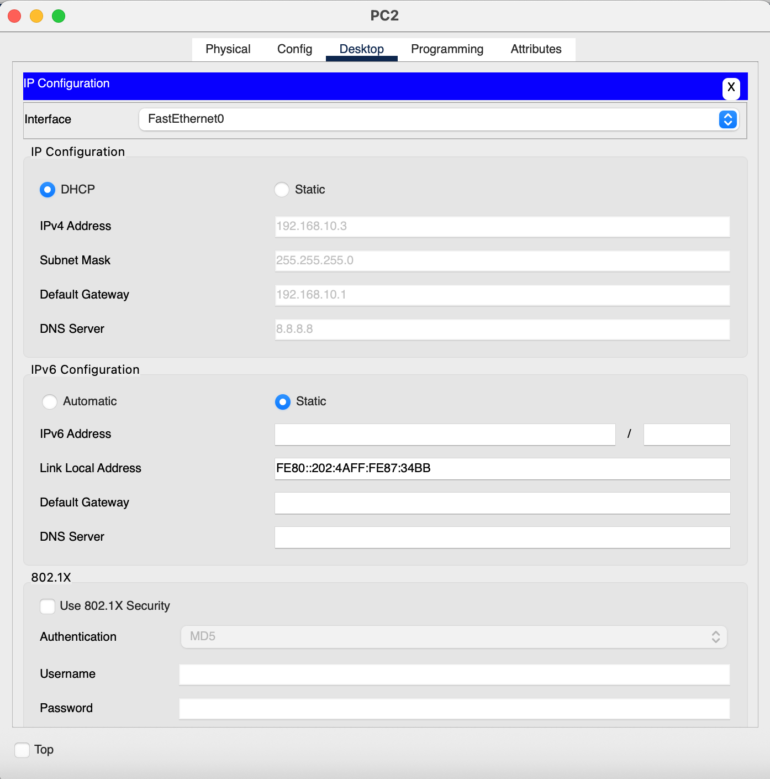

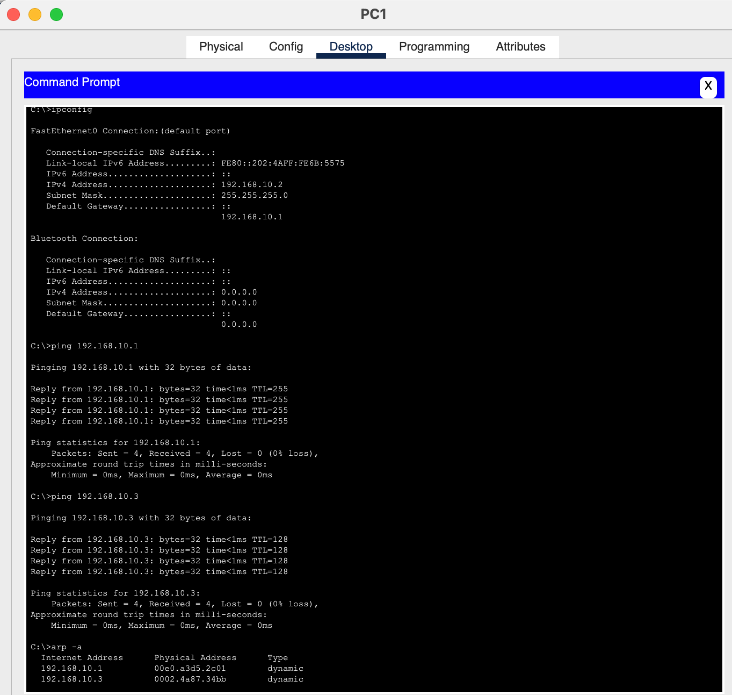

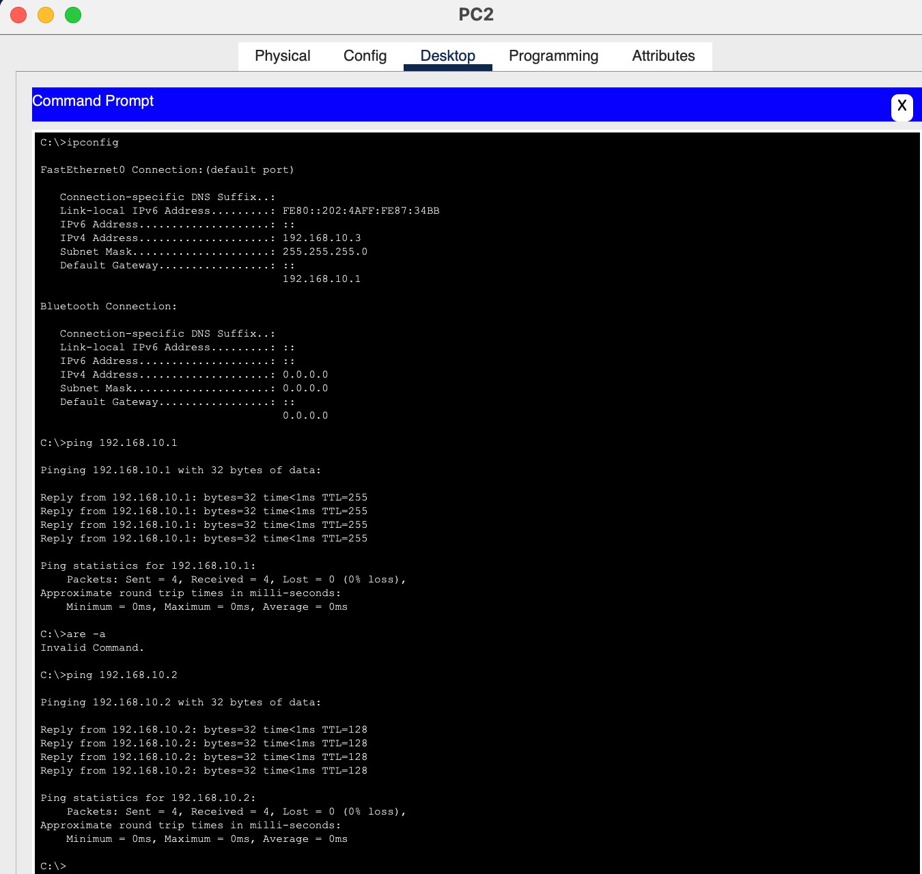

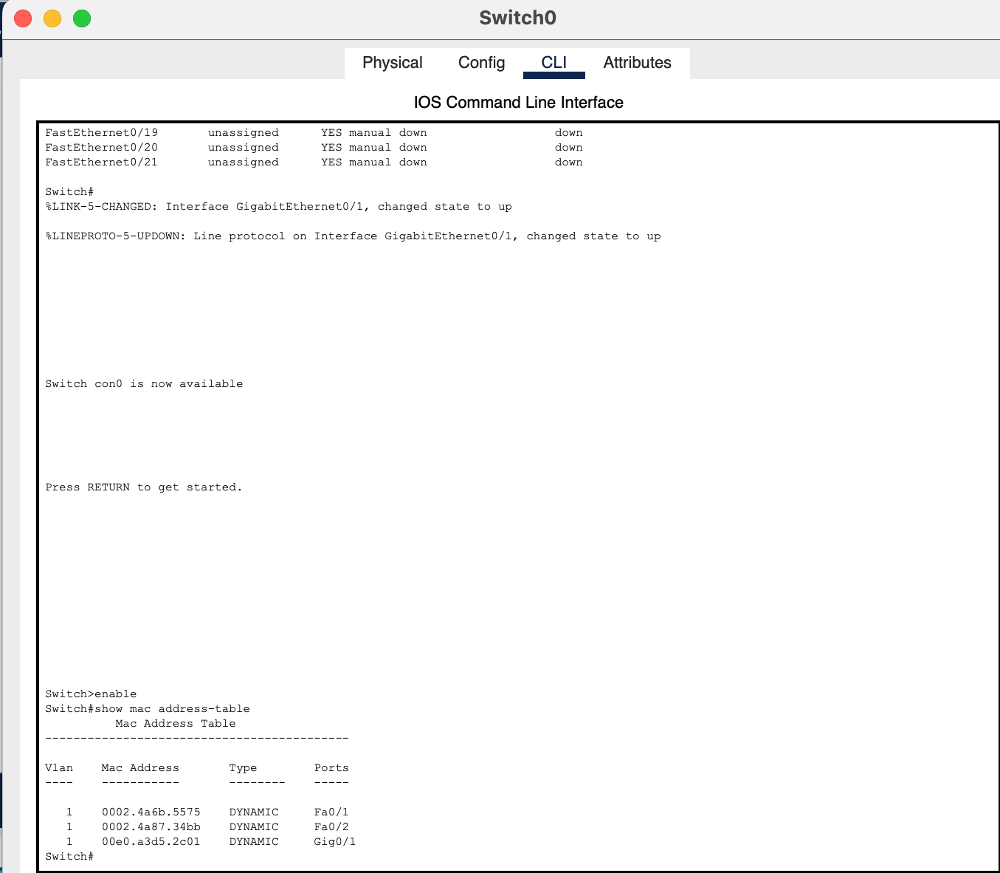

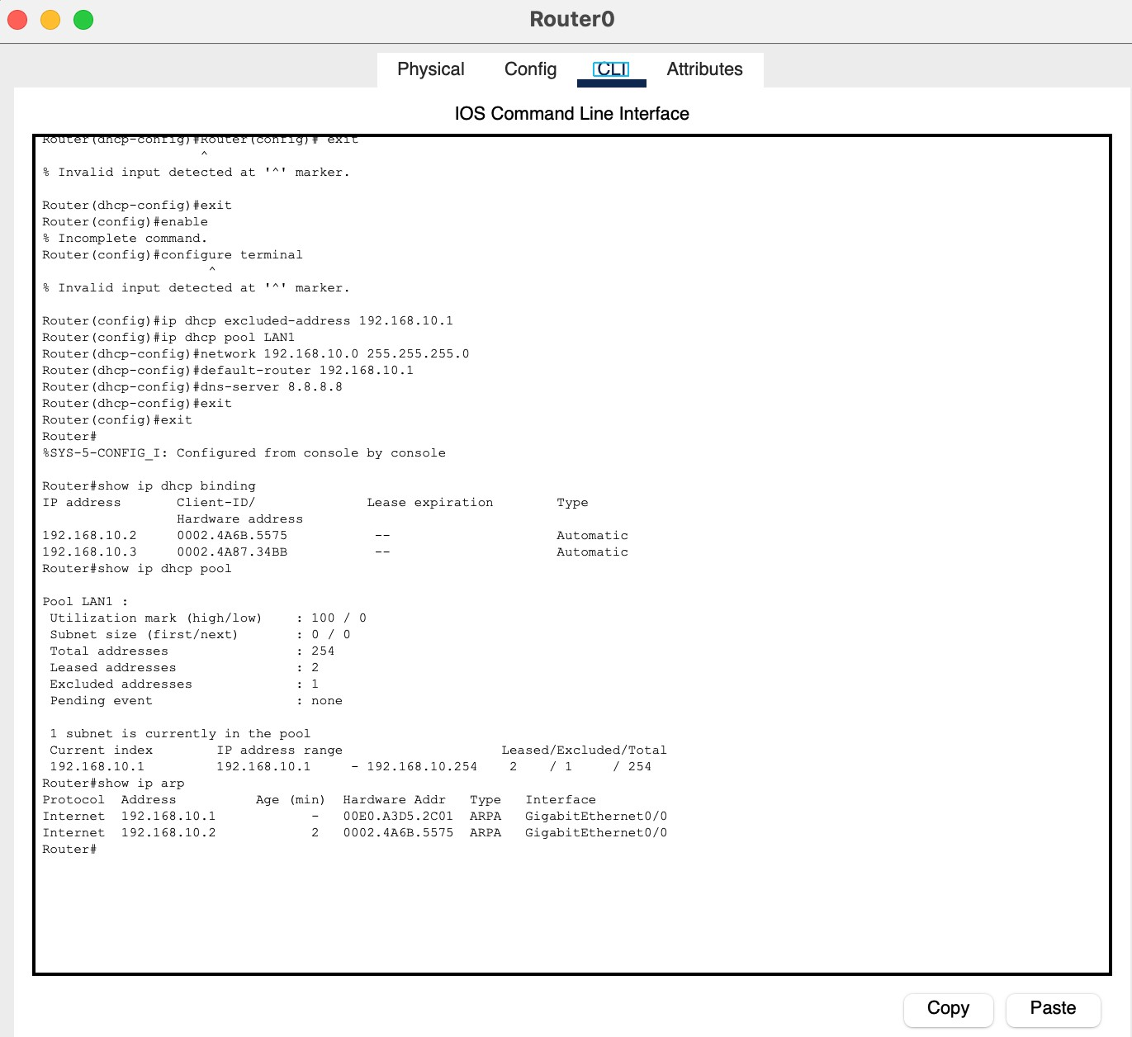

# Conclusion:

The lab demonstrates successful con7iguration of DHCP and ARP on a Cisco router and switch. PCs dynamically received IP addresses, and connectivity was veri7ied between all devices.